HIGH-LEVEL DESIGN DOCUMENT

**Health Insurance Data Analysis and reporting Using SQL Database and Power BI Tool**

**Version: 1.x**

**Created Date: 17/03/2023.**

Revision History

|  |  |  |  |
| --- | --- | --- | --- |
| Version | Date | Created By | Reviewed By |
| 1.0 | 21/03/2023 | Yesu Ratnam |  |
|  |  |  |  |
|  |  |  |  |
|  |  |  |  |
|  |  |  |  |

TABLE OF CONTENTS

Contents

1. Introduction 4

1.1 Purpose 4

1.2 Scope 4

1.3 Document Overview 4

2. System High-Level Design Overview 4

2.1 System High-Level Design Goals, Scope, and Objectives 4

2.2 High Level Architecture 4

3. System Design Consideration or Approaches 4

4. Deployment / Reporting 4

# Introduction

## Purpose

This document provides a comprehensive architectural overview of the Health Insurance Data. Hospital Name wise, Surgery name-wise, Gender wise location-wise, Category wise reports.

## Scope

* Data Loading,
* Data Cleansing,
* Data Transformations
* Data Visualization

# System High-Level Design Overview

## System High-Level Design Goals, Scope, and Objectives

**Scope:**

The Scope of POC is Load the Excel data to MS SQL Server Database. Then Import the data from MSSQL Server Database to Power BI which includes the scenarios related to Health Insurance Data – Build the visuals of Hospital Name wise, Surgery name wise, Gender wise location wise, Category wise reports.

The visualization report also provides insights related to Hospital Name wise, Surgery name-wise, Gender wise location-wise, Category wise reports distributed each year.

The dashboard provides a single point of view to analyze the Health Insurance business and build business strategy and future decisions.

**Objective:**

The client is looking to automate the reports in power bi.

## High Level Architecture

# System Design Consideration or Approaches

Our Approach is to Load Excel files to the SQL server database and then Import them to Power BI.

Once imported the data to Power BI then did some transformations using Power Query. Then load the data to the power bi desktop to design the data model.

# Deployment / Reporting

* Importing the data from SQL server database to Power BI and then provide the relationship between the dimension tables and fact tables.
* Based on the requirement I have created the calculated columns and measures.
* Once preparing the dataset I have prepared the reports.
* In my reports For Data Visualization used Clustered bar chart, Clustered column chart, slicer, card, Table and  etc.
* The visualization reports are related to the hospital wise total policy information report, Surgery wise to amount spent on surgeries report, gender wise total policy information report, location wise and category wise total policy and amount information report, hospital wise total policy information report.
* And then publish the report to power bi service.

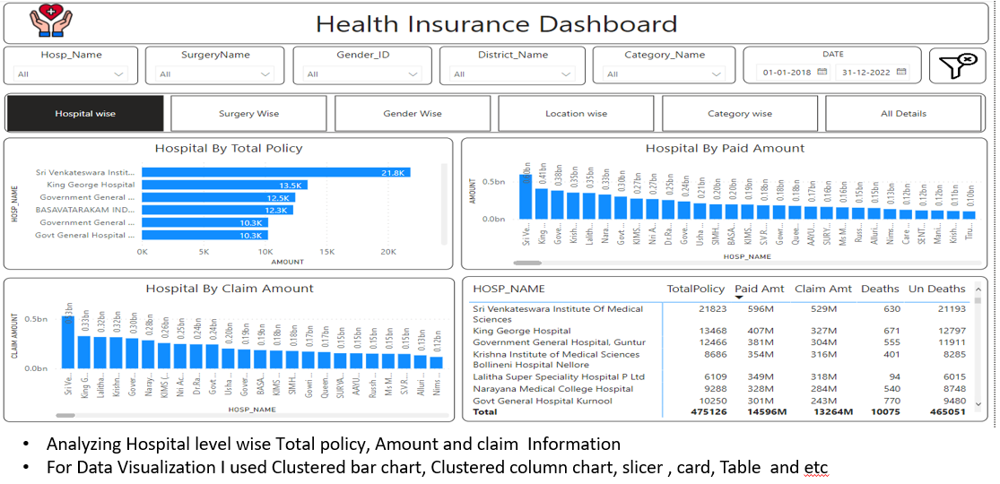

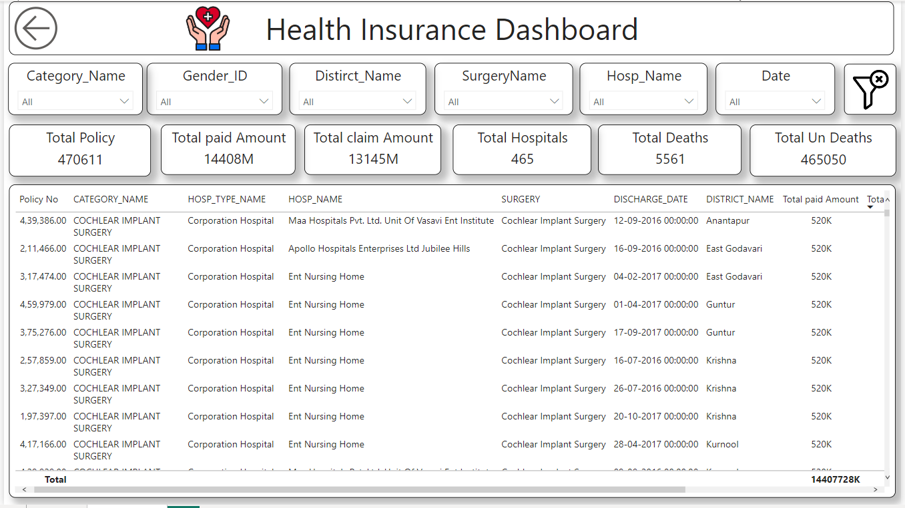

-------End of the Document------